Sandy Spring Civic Association
Ross Body Community Center, Sandy Spring, MD 20860
(Meeting Virtually by Zoom during Covid-19 Pandemic)

February 13, 2023 (Zoom meeting for 31st meeting in a row)
Attendance:
Board Members – Dr. Daryl Thorne, President; Basile “Whit” Whitaker, Vice President; Christine Hill Wilson, Treasurer; Douglas Farquhar, Recording and Correspondence Secretary
Other SSCA members – approximately 12
Guests: Councilmember Dawn Luedtke; her Chief of Staff Aaron Kraut; Judy Hruz, Greater Olney News
Attendance Total (approximate): 19

Meeting called to order: 6:32 p.m. by Daryl.

The meeting began with a presentation by Dawn Luedtke, Councilmember for our newly formed Councilmanic District, District 7. Dawn noted that she lives in Ashton. She said that District 7 is the second largest Councilmanic District in the County, and that four of the seven Montgomery County Police districts are located, at least partially, in her district. She discussed her Council committee assignments, and her legislative agenda. Of particular relevance to positions taken by the SSCA, she noted that she is working on securing funding for the bikeway along the north side of Route 108, on ensuring that the Ashton Village Center Implementation Advisory Committee has a meaningful role in development there, and on supporting use of speed cameras where the speed limit is as high as 45 mph (currently, speed cameras are restricted to roads where the speed limit is 35 mph or less).
In response to questions, she said that she does support the use of speed cameras as meaningful measures to modifying driver behavior, and she is interested in other “traffic calming measures.” She said that she is a cosponsor of a bill introduced by fellow Councilmember Will Jawando that would permit sharing of housing, renting out properties for up to 12 hours a day for use as offices, gyms, or pools, stating that this activity is happening anyway, and the County should move to regulate it. She acknowledged, though, that it is important that any uses are consistent with Homeowner Association requirements.
In response to other questions, she said that funds from the federal Inflation Reduction Act are not yet available at the state level, but might be tapped for resurfacing of Dr. Bird and Brooke Roads. As to “rank choice” voting (currently being tried in Takoma Park primaries), she said that she is in favor of it if it is the “will of the people.” Asked about the County Planning Board, she said that she is in favor of “more transparency and better legislative oversight.”
At 7:13 we moved on to other business. The January 2023 meeting minutes, which had been circulated before the meeting, were approved unanimously, with three corrections.
The Treasurer’s Report (attached) was read and accepted. Christine mentioned that applications for this year’s scholarships were circulated to schools and churches, with an application deadline of April 15.
For the traffic committee report, Marie Slater said that she would follow up with Officer McNickle about items discussed in our January meeting. She and Kathleen Wheeler discussed a walkthrough of Ashton and Route 108 by County and State transportation/highway officials and state and county elected leaders (a thorough report and photos are attached to these Minutes). There was a great deal of frustration expressed about the failure over many years to secure crosswalks at the Ashton intersection.
Daryl noted that Evan Glass, President of the County Council, will speak at our March meeting, and Liza Smith discussed several bills in the state legislature that the County’s Democratic Central Committee is supporting.
There was a brief discussion about changing the name of SSCA to the “Greater Sandy Spring Civic Association,” as a d/b/a so corporate papers would not have to be amended. There was a discussion about how the SSCS could better publicize its mission and its accomplishments.
The meeting was adjourned at 7:56 p.m.

Respectfully submitted,

Douglas Farquhar,
Recording and Correspondence Secretary

Approved:

SSCA FINANCIAL STATEMENT JANUARY 2023

Membership Checking Account

Operating Fund
1/17/2023 | Postage | (19.20)
1/20/2023 | Dues | 35.00
1/20/2023 | Postage | (19.20)
1/24/2023 | Dues - PayPal | 25.97
1/27/2023 | Dues | 45.00
1/30/2023 | Homestead website hosting | (23.74)
 |  | 43.83

Scholarship Checking
1/20/2023 | Postage | 19.20

19.20
$ 159.43

$119.29
Community Outreach Fund
 | Brought forward 01/31/2022 | 55.00
5/18/2022 | Donation | 30.00
Total |  | 30.00
 |  | 85.00

Balance | $203.26

Balance | $138.49

Scholarship Savings Account

1/31/2023 | Interest | 0.74
1/31/2023 | Deposit | 100.00

100.74
$ 3,492.99

Balance | $ 3,593.73

$ 2,587.02
Scholarship CD Account
1/4/2023 | Interest | 6.82

6.82

Balance | $2,593.84

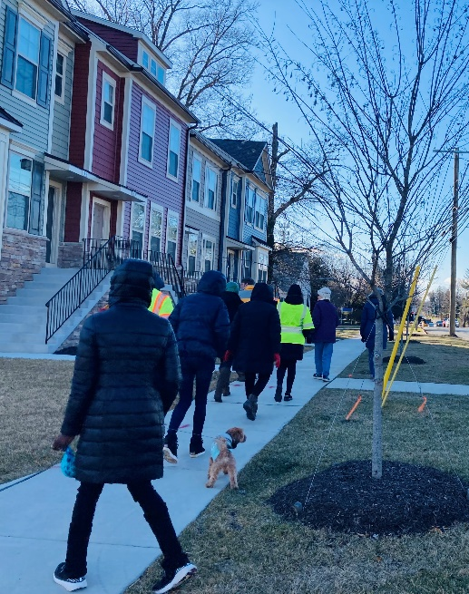

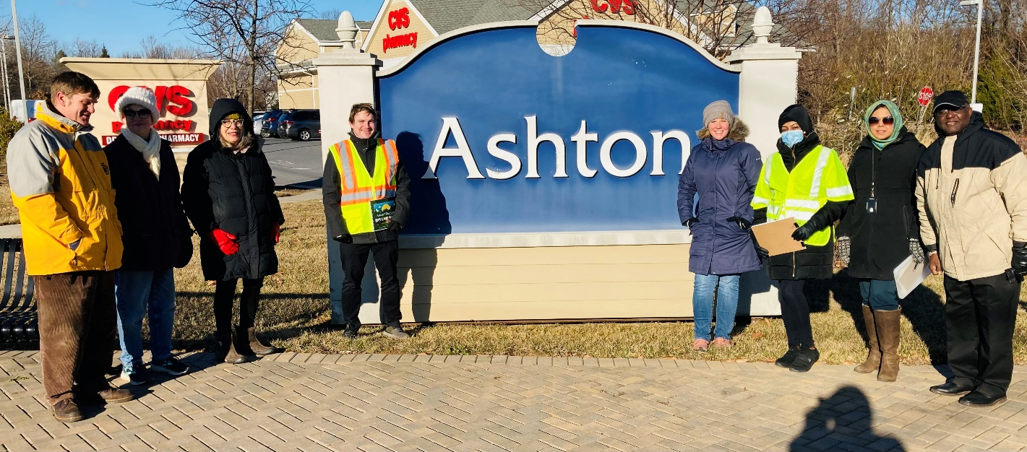
From: Bandeh, Jewru <Jewru.Bandeh@montgomerycountymd.gov>
Date: Sun, Feb 5, 2023 at 11:20 PM
Subject: Ashton Village Town Center Onsite Thru

Greetings,
I hope this email finds you well and warm.
IT SURE WAS A VERY BONE CHILLING COLD FRIDAY AFTERNOON. Nonetheless, members of the Ashton Town Center Advisory Committee and staff from the State and County Departments of Transportation and Planning braved the cold winds to conduct a tour of the AVTC to see, experience in real time and access road and pedestrian safety related issues the community is worried about and wants addressed.
Next steps-A report/response from SHA/MCDOT resulting from the walk-through. The AVTCAC hopes to develop short, mid and long term recommendations (viable solutions ) in collaborative partnership with elected, County and State officials, area citizens and businesses. The attached document below (received from the AVTC Advisory Committee) highlights specifically most of the major concerns discussed Friday. Thanks to the AVTCAC.
——————————————————————-
Pressing roadway and pedestrian safety issues facing residents in the area of the Ashton Village Town Center:

There existing road intersection itself is inadequate and unsafe and warrants urgent review and actions.

1. Routes 108 and 650 are too narrow to accommodate smooth traffic flow across the Ashton intersection. As a palliative, the authorities have, it seems, required traffic traveling south on R650 to stop several meters from the intersection itself to facilitate safe turning North from Eastern side of R108 onto R650. Larger vehicles inadvertently cannot make the turn without crossing over into the left lane of R650.

2. There is no turn arrow for traffic turning South onto R650 from the Eastern side of R108, and the lanes are simply too narrow, or restrictive.

3. Upon crossing from the East on R108 at the intersection, traffic in that lane find themselves in a Right Turn Only lane and must immediately shift over to the left to continue freely along the West side of R108. This points to the inadequacy of the number of lanes in the intersection.
4. The approach to the intersection from the West on R108 is also inadequate since traffic going straight across must wait until those turning left are able to do so. Otherwise, such vehicles are forced to enter the right (Turn) lane which is inadvertently crowded by traffic seeking to go South on R650. One clear problem is that length of the wider road area on the right of R108 from the West might be too short.

5. There is urgent need for an electronically-managed pedestrian walkway on the R108 to facilitate safe pedestrian crossing at or near to the intersection. The plans for residential and commercial developments in the Southeast corner of the intersection also warrants that similar pedestrian crossings on R650 be integrated in any those development plans to facilitate safe crossing by pedestrians in the area. High School students who cross the R108 daily to go to the Ashton Village Center shops, as well as residents from Ashton Way who cross over to walk (many with their dogs) along Hidden Garden Lane, to the Woodlawn Park, or along R108 to the high school track, currently face safety hazards negotiating the busy traffic.

6. The pedestrian walkways at or near the intersection are inadequate or absent. In particular, there is no walkway on the northern side of R108 in the vicinity of the High School thereby forcing students to walk on the narrow embankments to get to the Seven-Eleven or other shops in the Ashton Village Center Mall. The pedestrian walkway along the southern side of R650 is also inadequate—it needs to be extended to at least the current Cricket Bookstore to allow pedestrians to/from nearby residences or businesses. It is assumed that the new developments planned on the Eastern side of R650 at the intersection, will also include adequate sidewalks for pedestrian or business users. A multi-use path along this route to Ednor Road would be very helpful as discussed below.

At a broader level, bike/multi-use paths in the general area are needed.

Bikers and pedestrians face safety hazards on the roads bordering the 40 acre Woodlawn Park, namely on R108, Norwood, Ednor, and R650. For these reasons, bikers/walkers from Ednor Road, now use Hidden Garden Lane to get to R108. We note the indicative plans for a bike/multi-use path along the Northwestern side of R108 towards Ashton Village Center (from Norwood Road). We also note the operational plans by the County to extend the bike paths along Norwood and Dr. Bird roads. We therefore would recommend an early extension/completion of the bike/multi-use paths along R108 to Ashton Village Center, continuing along R650 to Ednor Road. This would be exceedingly helpful to residents and those pedestrians or bikers who wish to go to the Woodland Park, or simply to easily and safely enjoy the country roads in the area.

Thank you,

Jewru Bandeh, Director
East County

